Carbon Reduction Plan
Supplier name: ………WEMEC ltd………………………………………………………….
Publication date: ……01/10/2025……………………....................................................

Commitment to achieving Net Zero
WEMEC Ltd is an established consultancy providing customer support, project delivery and technical services across multiple client locations, with business travel undertaken where required for customer meetings, site support and overseas engagements. WEMEC Ltd is committed to achieving Net Zero greenhouse gas emissions by 2040, ahead of the UK Government’s 2050 legal target. This plan sets out the company’s current emissions position and the practical steps being taken to reduce emissions from business travel, premises energy use, operational activity, purchased services and wider supply-chain impacts.

Baseline Emissions Footprint
Baseline emissions are a record of the greenhouse gases produced before the introduction of additional carbon reduction measures. For WEMEC Ltd, the baseline reflects consultancy operations supported by customer travel, business premises and operational energy use, occasional overseas business travel, purchased goods and services, and courier activity.
Baseline emissions are the reference point against which emissions reduction can be measured.

Current Reporting Year: 2025
Additional Details relating to the Baseline Emissions calculations.
Electricity emissions relate to business premises and operational electricity consumption, including office equipment, IT infrastructure, lighting and associated facilities activity. The historical figure has been retained pending updated supplier and meter data.
Gas emissions relate to operational heating and retained premises activity. This figure should be reviewed annually against supplier, premises and metered consumption data.
Petrol usage relates to customer travel, site attendance and business mileage by car. The retained activity level remains plausible for consultancy operations involving regular customer engagement, but should be replaced with actual mileage and fuel records at the next annual review.
Scope 3 activity includes courier services, purchased goods and services, employee business travel not captured in Scope 1, client-related travel, waste generated in operations and approximately four overseas business visits per year. No emissions figures have been changed in this version; these categories should be recalculated using the 2025 UK Government conversion factors when full activity data is available.

Baseline year emissions:
EMISSIONS | TOTAL (tCO2e)
Scope 1 | 7.3tCO₂e
Scope 2 | 5.9tCO₂e
Scope 3  (Included Sources) | 1.9tCO₂e  Included sources: business travel not owned or controlled by WEMEC Ltd, overseas flights and hotel stays where applicable, courier services, purchased goods and services, and waste generated in operations.
Total Emissions | 15.1tCO₂e  Figure sense check: the total has been retained because it is plausible for consultancy operations involving client travel, retained premises activity, purchased services and approximately four overseas visits per year. The category allocation should be reviewed at the next annual review using updated activity data and the latest conversion factors.

Emissions reduction targets
To continue progress towards Net Zero, WEMEC Ltd has reviewed this Carbon Reduction Plan against the current public procurement requirements. PPN 006 replaces PPN 06/21 for procurements under the Procurement Act 2023 and Procurement Regulations 2024, while retaining the requirement for suppliers to publish a Carbon Reduction Plan, evidence a commitment to Net Zero and report Scope 1, Scope 2 and relevant Scope 3 emissions.
Our commitment to Corporate Social Responsibility is to operate as a responsible partner to the people, businesses and communities we work with. We will continue to measure emissions annually, reduce emissions wherever practical, and only consider credible offsetting for residual emissions that cannot reasonably be eliminated.
WEMEC Ltd’s largest practical opportunities are expected to be in business travel planning, low-carbon vehicle choices, premises energy efficiency, supplier selection and improved Scope 3 data. The 2025 UK Government conversion factors should be used for future recalculation of electricity, gas, petrol, air travel, hotel stays and other activity data.
Business travel and transport emissions will be managed by using online meetings where appropriate, combining customer visits where practical, prioritising rail over car or air where feasible, and reviewing whether each overseas visit can be avoided, combined with other meetings, or undertaken by lower-carbon travel. Where air travel is necessary, WEMEC Ltd will record the route, class of travel and hotel nights so that emissions can be reported more accurately.
The current total of 15.1tCO2e is reasonable for consultancy operations involving regular travel to client locations, retained premises emissions, supplier activity and approximately four overseas visits per year. The split between Scope 1, Scope 2 and Scope 3 should continue to be improved at future reviews as better mileage, energy, travel and supply-chain data becomes available. We project that emissions will decrease to 11.25tCO2e by 2030, retaining the existing reduction target of 25%.

Progress against these targets can be seen in the graph below:
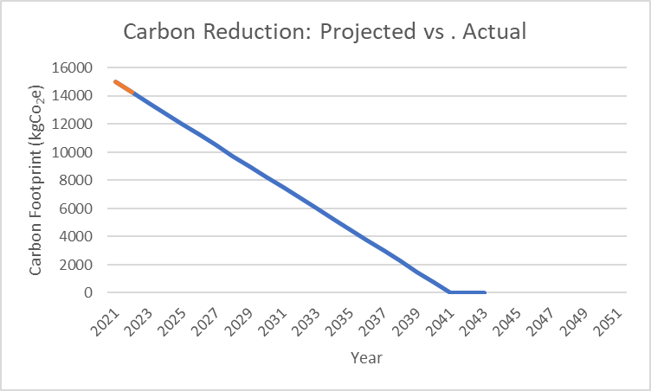

Carbon Reduction Projects
Completed Carbon Reduction Initiatives
The following environmental management measures and projects have been implemented or are currently in use. These are proportionate to WEMEC Ltd’s operating model and will remain in effect when performing relevant contracts.
- Online meetings are used where appropriate for internal discussions, supplier engagement and customer meetings where site attendance is not required.
- Customer travel is planned to combine visits, reduce repeat journeys and prioritise lower-carbon options where practical.
- Overseas travel is limited to essential business needs and reviewed before booking to confirm whether remote attendance is suitable.
- Courier use is consolidated where possible to avoid unnecessary collections, deliveries and returns.
In the future we will continue to develop further measures, including:
- Introduce an annual activity-data log covering business mileage, rail journeys, flights, hotel nights, courier activity, purchased IT equipment and premises energy data.
- Recalculate emissions annually using the latest UK Government conversion factors and record any changes in methodology.
- Prioritise efficient delivery methods, rail travel and effective route planning before car or air travel, subject to customer requirements and operational practicality.
- For future vehicle replacement, prioritise hybrid or electric options where range, customer travel patterns and charging access make this practical.
- Improve operational energy efficiency through efficient IT equipment, lighting controls, heating controls, renewable electricity tariffs where available and regular review of premises energy performance.
- Request relevant emissions information from key suppliers, travel providers and courier partners to improve Scope 3 data quality over time.

Declaration and Sign Off
This Carbon Reduction Plan has been completed in accordance with PPN 006: Taking account of Carbon Reduction Plans in the procurement of major government contracts, the associated technical standard and published reporting guidance. It reflects WEMEC Ltd’s operating model as an established consultancy and will be reviewed annually as activity data improves.

Emissions have been reported and recorded in accordance with the published reporting standard for Carbon Reduction Plans, the GHG Protocol Corporate Accounting and Reporting Standard and the applicable 2025 UK Government greenhouse gas conversion factors for company reporting.

Scope 1 and Scope 2 emissions have been reported in accordance with relevant Streamlined Energy and Carbon Reporting principles where applicable. The required subset of Scope 3 emissions has been reported in accordance with the published reporting standard for Carbon Reduction Plans and the GHG Protocol Corporate Value Chain (Scope 3) Standard. Future reporting should place particular emphasis on business travel, flights, hotel stays, purchased goods and services, operational waste, courier activity and supply-chain data quality.

This Carbon Reduction Plan has been reviewed and signed off by the board of directors (or equivalent management body).

Signed on behalf of the Supplier:
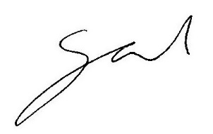

…………………………………………………………………. Date: ……01/10/2025………………….……….

